Name: . - ( )

Class : Primary 6

CHIJ ST NICHOLAS GIRLS’ SCHOOL (PRIMARY)

§ aap ae ~  
4% LiPo op ‘  
y Pay \  
AS. mugia be’  
ad ts, BNE NO catecad Wl hy),  
AGL. 32) Bi SC A 2,  
ae i nee as  
ia Boece 4  
\ = ss Z  
a as “i  
Sg STEADFAST i DUT  
CLAN 9 Se ays  
~, Se  
e ob re We

Primary 6

Termly Assessment

25 February 2019

Englisn Language

Paper 2 Booklet 8

Duration of Paper (Booklets A & B)}: 1 in 30 min

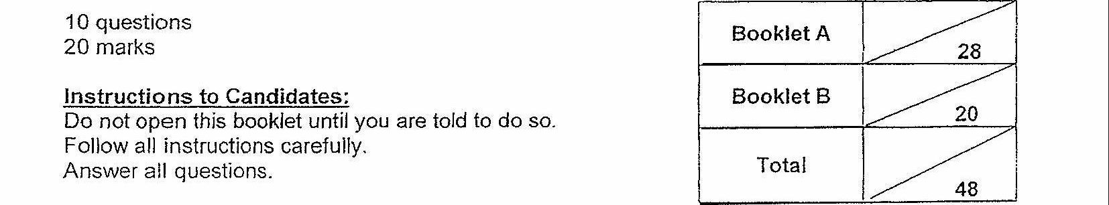

10 questions  
20 marks

Parent's Signature:

This booklet consists of 5 printea pages.