ALL ANSWERS MUST BE IN COMPLETE SENTENCES UNLESS OTHERWISE STATED. |

29 How did the author first know thai the wails of the young child were very joud? [7m]

LE rahe SP rfid rarer yy Sy Sr is hrrenrrry—r7F-7-P— set-up

nee ee fay Pa +e Serer bre ENPYPPTUNNUueihdicnephnipastiper.

30 =©What had caused the young child io cry? [1m]

TOON Ea eee ee ey gS SSS SS fils gp rill lsd ahhh ill lth tcetheneeneenheanee

34 VVny dio the author need the young child to be still? (line $9) [im]

ne |

a i et 7 SS errr urs SS pS rrr? ss li lS lt rll ESTs

32. ~Look at the tabie below. Whai do ihe words in the left column refer to in the passage?  
Write your answers in the column in the right. (2m)

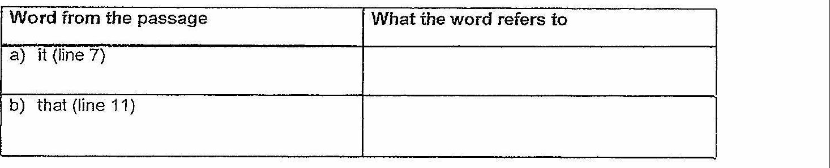

35 = rill in the following table by identifying the correct word(s) from the passage. [3m]

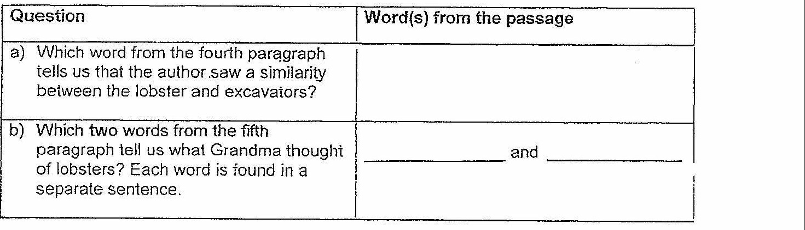

(GO on to the nexi page} |