33 = Fill in the blanks below to show how the author related to the rubber toy. [3m]

a) After the  
fishmonger passed [> he felt that she was a lady  
the rubber toy io  
the author

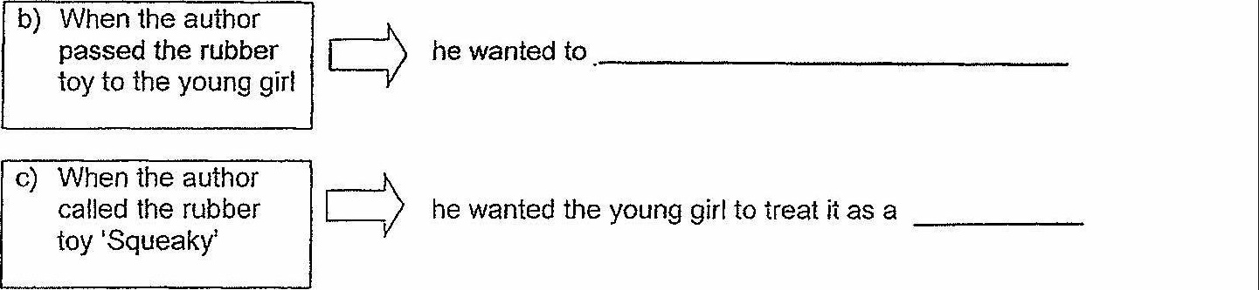

-ND OF PAPER

So