ANSWER KEY

YEAR : 2019  
  
LEVEL : PRIMARY 6  
  
SCHOOL : CHIJ NICHOLAS GIRLS’ SCHOOL  
SUBJECT : ENGLISH  
  
TERM \*CAY

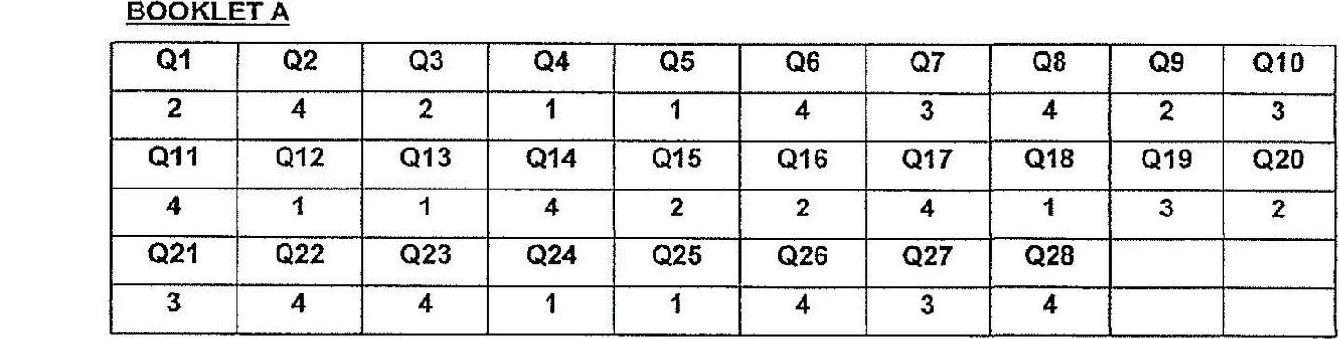

BOOKLET B

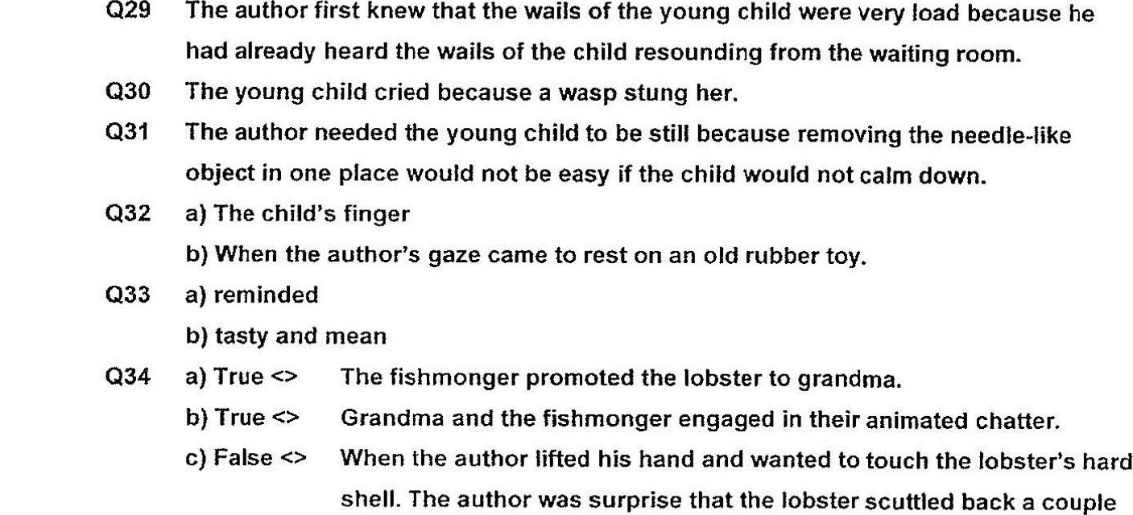

Q35 The author gave a loud well and jumped up with a start.  
  
Q36 Grandma was pleading for someone to help Ali pull the Jobster off his finger.  
Q37 = The fishmonger did not think that anyone would buy a one-claw lobster, and the  
fishmonger was sure that the two-claw lobster could fetch a good price.  
  
Q38 a) kind

b) make the young girl fee! better.  
c) friend.