14. The figure below shows a rectangle. ABC is an equilateral triangle. | vwnite in  
. this

~Ppace

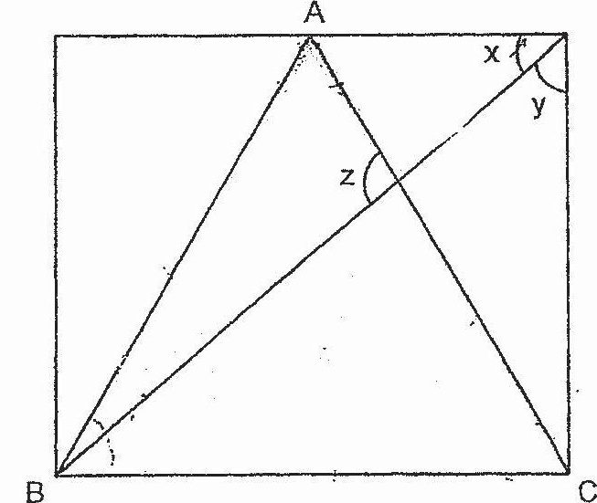

The ratio of 2x to Zyis,4 5. Find the value of 2 z.



