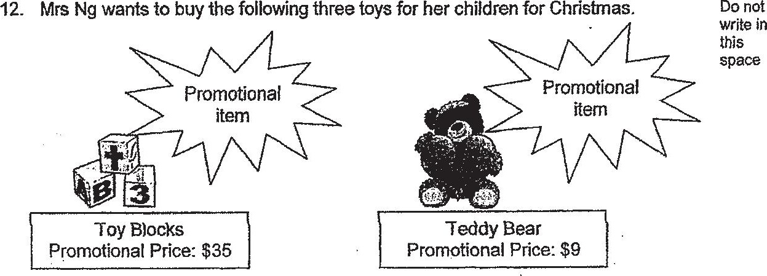



She has two options for her purchase.

Option 1: : so  
Use her membership card and get a 15% discount on items that are not on Ooty .  
promotion. BO

Option 2: : :  
Use a $10 discount voucher to get $10 off her total purchase,



Which option should she choose if she wants to enjoy more savings? How much  
more savings would she enjoy if she chooses that option? :



