14. Sulyn filled two types of pails, large and small, with some red paint that she had — | Bom  
bought. She filled 3 identical large pails and 4 identical small pails to the brim pine  
with 10.1 fof red paint. oO spact

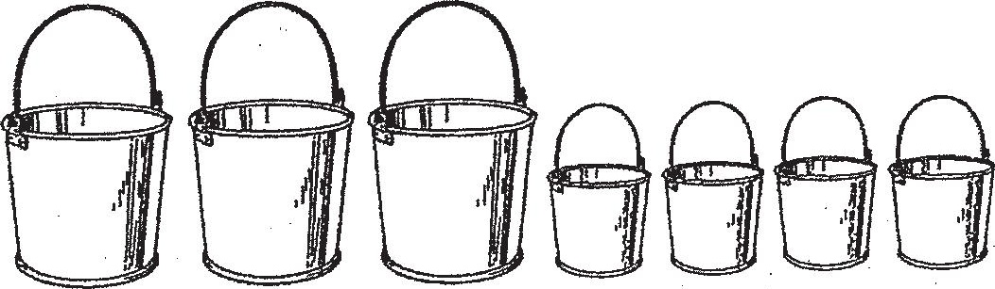

She could not fill another large pail to the brim with the remaining amount.of red  
paint as she was short of 0.3 £ of red paint. Hence, she filled another smail pail te  
the brim and had 0.5 2 of red paint left.

(a) How many more litres of red paint can each large pail hold than each small  
pail? ,

(b) How many litres of red paint did Sulyn buy?



