15. A wooden path of length 19.8 m is completely covered with similar wooden planks, | vo not  
following the pattern shown below. The width of the path is 110 cm. write in

| Space

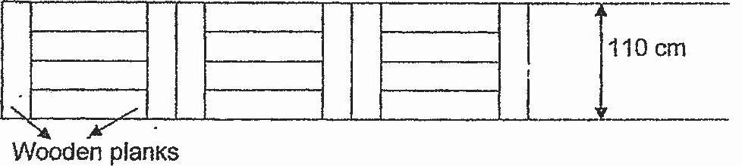

(a) What is the breadth of each wooden plank?

Ans : (a) _ [it 1

