17. Ping Ting draws some triangles that follow a pattern. The first four figures are Do not  
shown below. | write in  
. this  
_ space

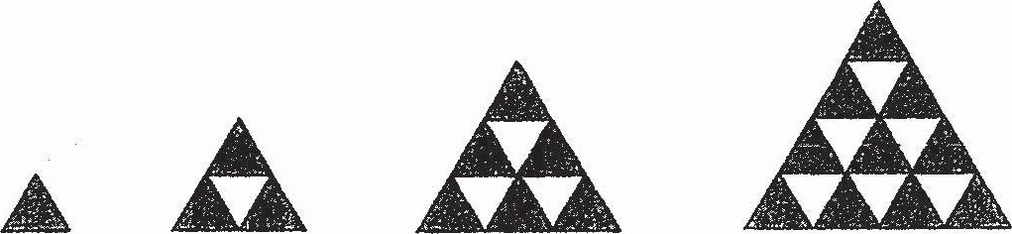

(a) Study the pattern and complete the table below.

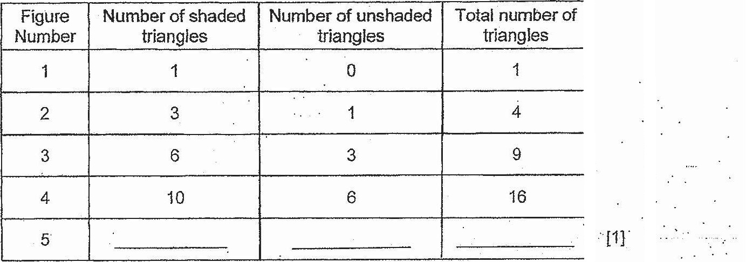

(b) What is the total number of triangles in Figure 17?

(c) How many unshaded triangles will there be in Figure 25?





“*End of Paper**

16  
www.TestPapersFree.com