Do not  
write in

3. ABCD is a rhombus, Find < DAO.



Space

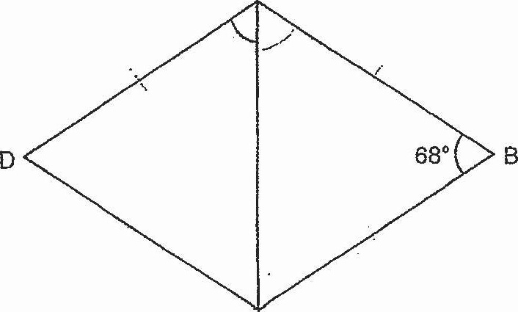



4. There are some triangles and circles. 4 circles are removed. What percentage of |

