s Do not  
  
5. The figure below is made up of 3 trianglessADE, BCE and°CDE. ADC and BCD write in  
are 2 identical right-angled triangles. Point E is the midpoint of Line AC and Line oe  
Bb.

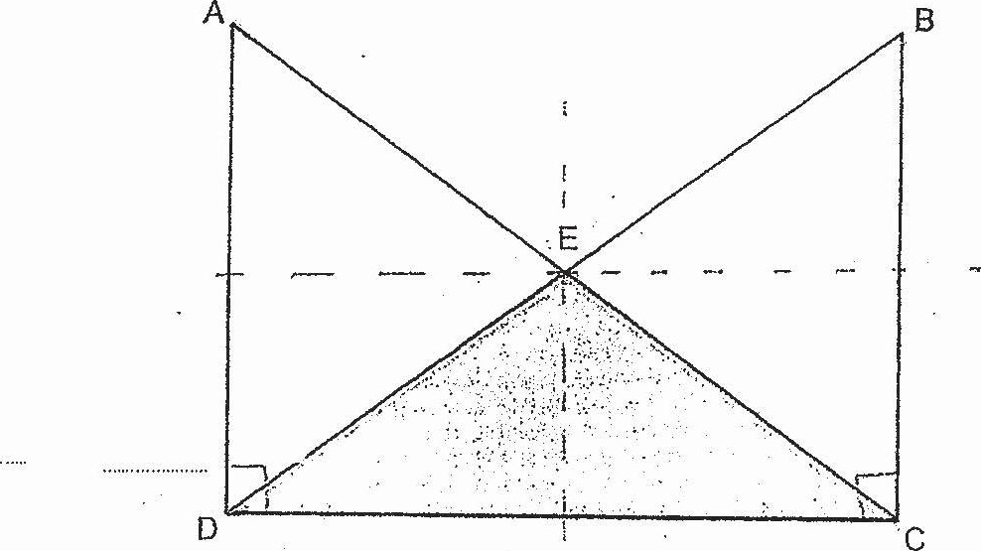

2 Each statement-below-is-either true, false or not possible to tell from the  
ee . information given. For each statement, put a tick () in the correct column.

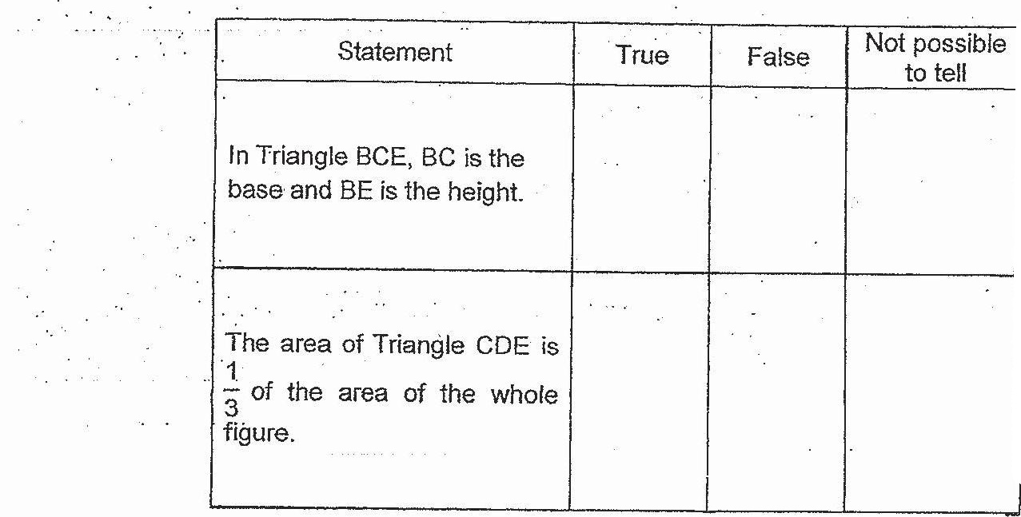

4 :  
www.TestPapersFree.com