a7  
Bt ry  
WE  
< } gf  
Sach xm ie  
nag

CATHOLIC HIGH SCHOOL









(BOOKLET B)







Total Time for Booklets A and B: 1 hour | Bookletal sd



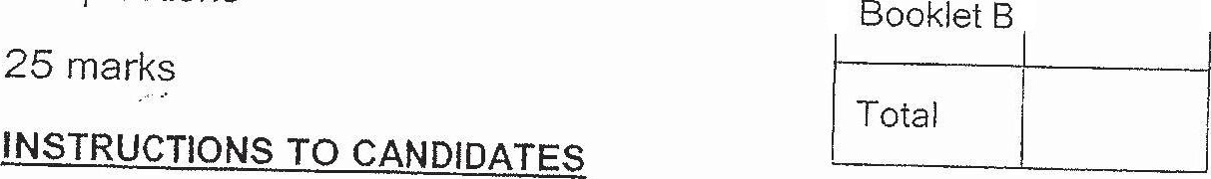



Do not turn over this page until you are told to do so.

F Olow ail instructions carefully.

Answer all questions.

VVrite your answers in this booklet

Tne use of calculators is NOT allowed.