19. Use all the digits 7, 2, 1, 8 to form the number closest to 8000. Do not write  
in this space



20. David took 2 hours to drive 160 km from Town A to Town B. Then he  
drove 110 km for an hour to Town C. What was his average speed for  
the journey from Town A to Town C?

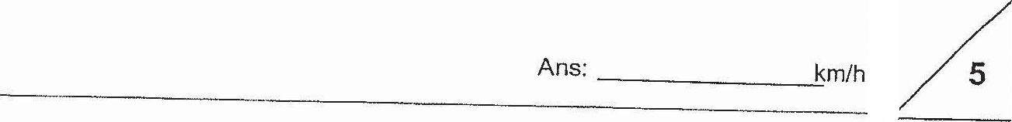

Tota] marks for questions 16 to 20