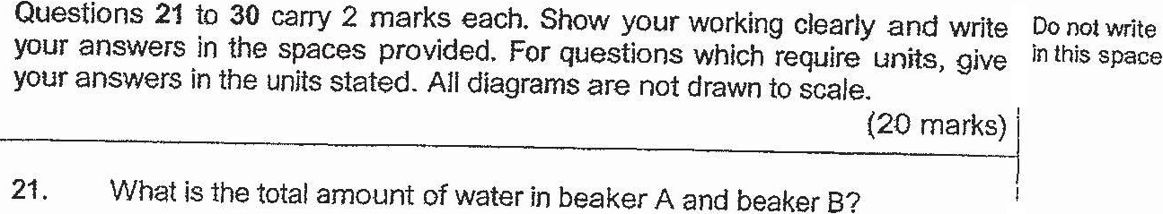

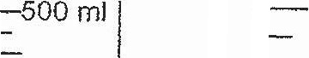

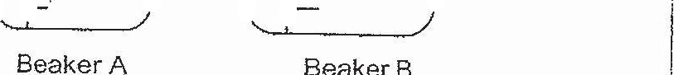



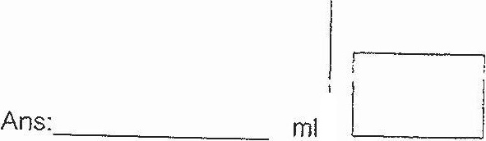

j  
  
22, In the dot square grid, figures A and B are drawn using straight lines |  
and semicircles. Figure C is drawn using straight lines and quarter  
  
circles while figures D and E are drawn using only straight lines. !

