23. Mrs Lim wanted to buy 12 oranges but found that she needed another Do not wite  
$2. She bought 4 oranges instead and had $5.20 left. What was the | in this space  
cost of 4 orange?

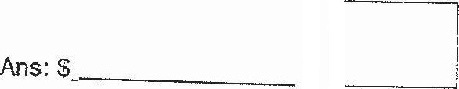

24, The cost of a present was shared among Samuel, Jack and Daphne.  
The ratio of the amount of money paid by Samuel and Jack was 1 23.  
The ratio of the amount.of money paid by Jack. and Daphne was 4 : 7.  
What was the ratio of the least amount of money paid to the most  
amount of money paid?

