29, Bala bought 15 boxes of pens and pencils. There were 103 pens and | Do not write  
pencils altogether. How many boxes of pencils did Bala buy? in this space

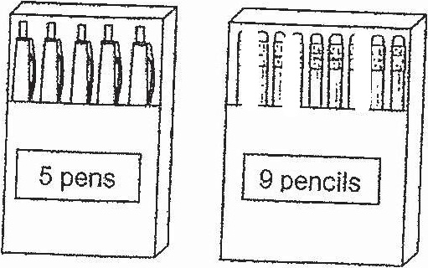

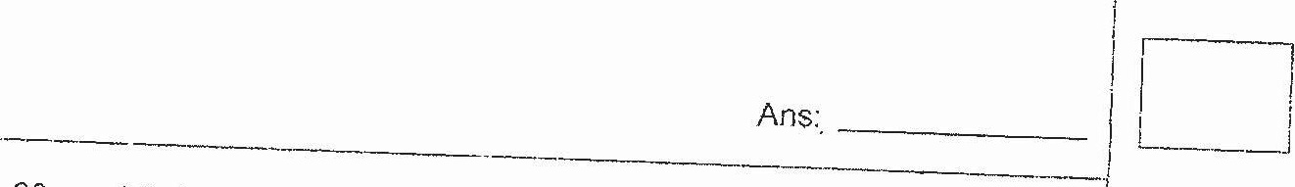

i  
26. A fruit seller packed 1200 Mangoes into bags of 6 for sale, The price of !  
each bag was $8.20. How much did the fruit seller collect from the |  
  
sale? |  
Se  
  
|  
  
i f : [  
  
ee i  
  
( fy |  
  
1 j

