af. Eric's average marks for his English, Mathematics and Science tests Do not write  
was 75. His average marks became 60 after the marks for his Chinese | in this space  
test was included. The passing mark for each test was 50.

£acen of ihe statements below is either true, false or not possible to tell  
from the information given. For each statement, puta tick (”) to  
indicate your answer.



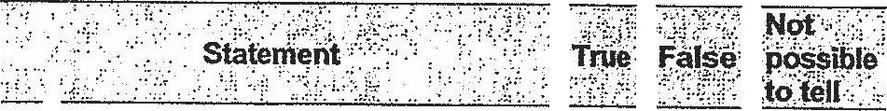

(a) Enc scored 75 marks for his Science  
tect.

(oD); Enc passed his Chinese test since  
his new average marks of 60 was  
above the passing mark of 50.

20. ABCE Is a rectangle with a length of 20 cm and a breadth of 10 cm.  
Triangle EBD which has an area of 40 cm?, overlaps triangle ACD.  
What is the area of triangle ACD?

