29. Fatihah used biack and white beads to form a paitern in the following | Do not write  
figures. in this space







she used 49 black and white beads to make a figure that followed the  
above pattern. What was this figure number?

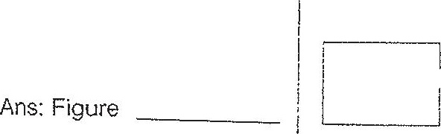

30. Ata school event, 57 red balloons and white balloons lined one side of ,  
a corridor. There are at east 4 red balloons between 2 white balloons. |  
  
What is the largest possible number of white balloons along the |  
corridor? |  
  
|

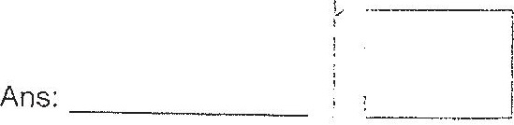

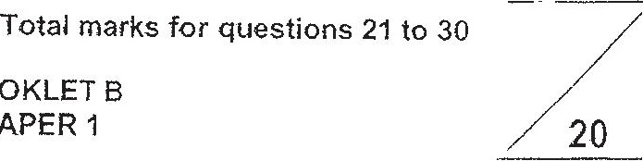

END OF BOOKLET B  
END OF PAPER 14