3 y  
WY  
Bee/ Ww  
ee Bs

CATHOLIC HIGH SCHOOL











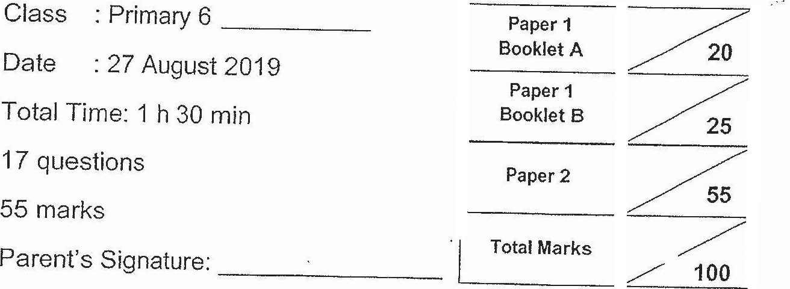













Vo not turn over this page until you are told to do so.



Answer all questions.

Write your answers in this booklet.

ihe use of an approved calculator is expected, where appropriate.