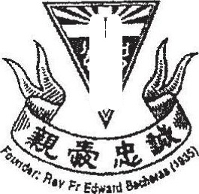

CATHOLIC HIGH SCHOOL













Class : Primary 6 ee





15 questions





Do not turn over this page until you are told to do so.

- Oliow all instructions carefully.

Answer all questions.

Shade your answers in the Optical Answer Sheet (OAS) provided.

The use of calculators is NOT allowed.