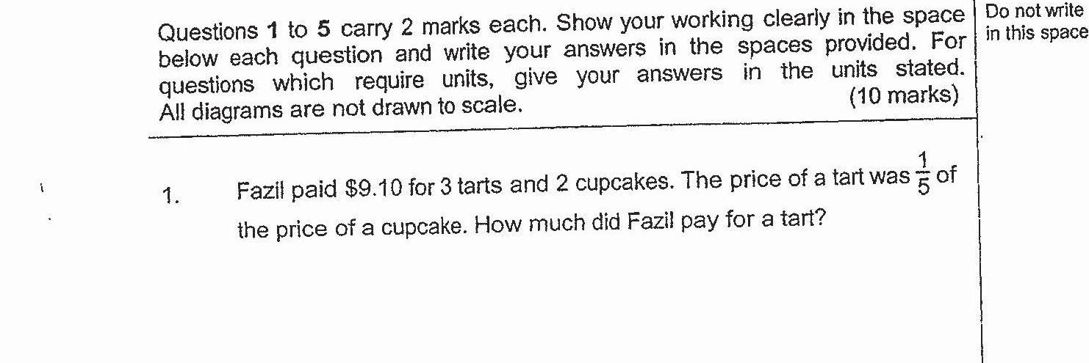

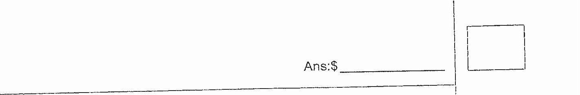

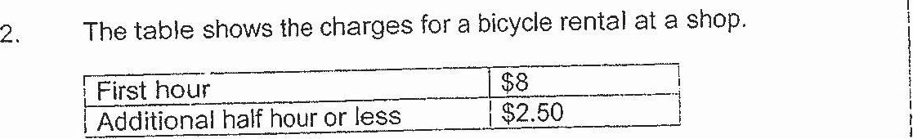

Fred rented a bicycle for 3 h 20 min. How much did he pay for the  
rental? |

