4, The square grid below shows the plan of a school compound. Do not wiite  
in this space

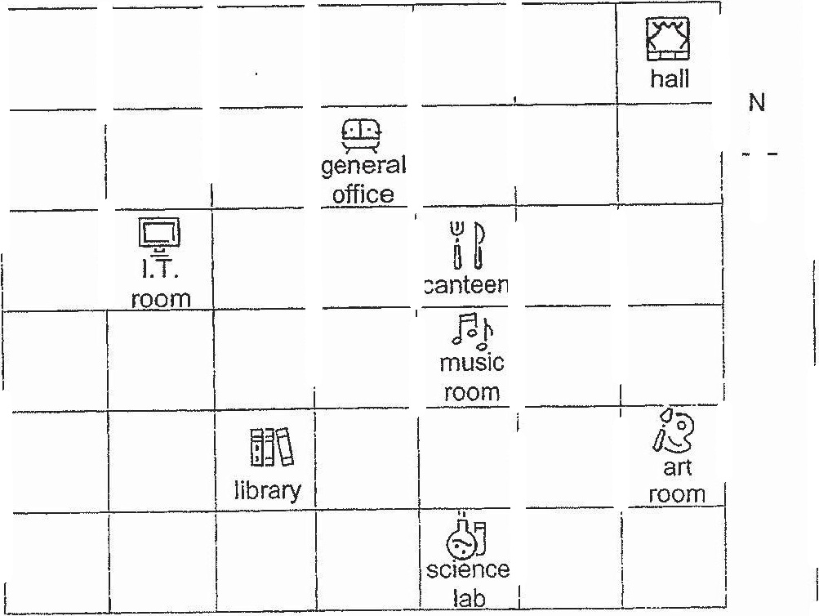

(a) Ned stood at the canteen facing the art room-after making a  
i. turn in the anti-clockwise direction. Where was he facing at |

(b) Ned fixed a location to meet his mother after school. The location |  
of the meeting place was to be north-east of the science lab and  
east of music room. Puta tick (~) in the square where the meeting  
place was.

