5. A stack of 7 identical flower pots were arranged as shown in Figure 1. Do not write  
Figure 2 shows the stack after it had been re-arranged and 4 more | in this space  
identical flower pots were added to it. What is the height of one flower

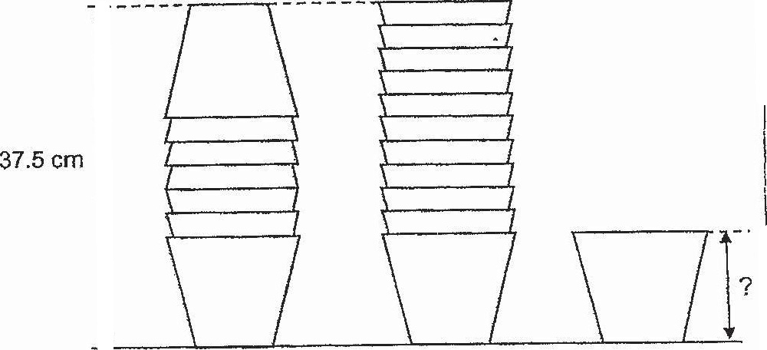

Figure 1 Figure 2 Flower pot |



