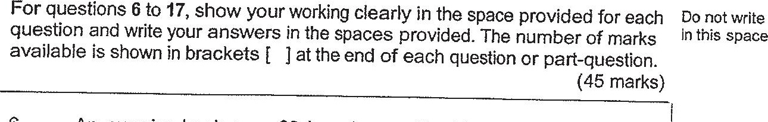

\ 6. An exercise book was $2 less than a file. The total cost of 3 such  
. exercise books was $k.

(a) Express the cost of 6 such exercise books in terms of Kk in the  
simplest form.

(0) Suresh bought 3 such files and was given a discount of $1. |  
How much did he pay for the 3 files? ,  
Express your answer in terms of & in the simplest form. {

