f. AB js a Jine drawn on a grid below.

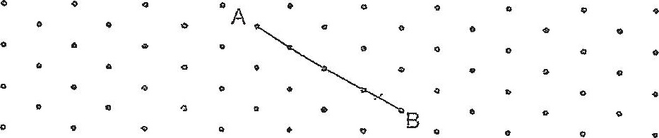

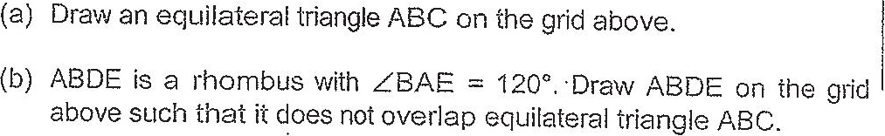

(c) What Is the ratio of the area of the triangle ABC to the area of the  
figure EDBC?





