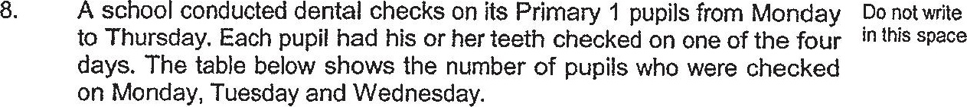

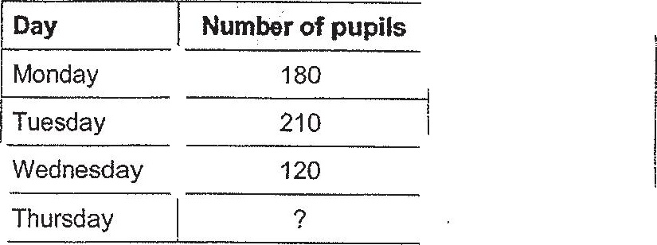

(a) The number of pupils checked on Thursday was a 20% decrease  
from that checked on Wednesday. What was the number of pupils  
checked on Thursday?

(b) What was the percentage increase in the number of pupils checked |  
on Tuesday compared to Monday? ,  
Give your answer correct to 1 decimal place.

