9. The diagram shows 2 identical quarter circles and 2 identical | Do nci write  
rectangles. The 2 identical rectangles overlap at ABCD to form a| inthis space  
square with an area of 49 cm?. The perimeter of the shaded part is  
95.2? cm.

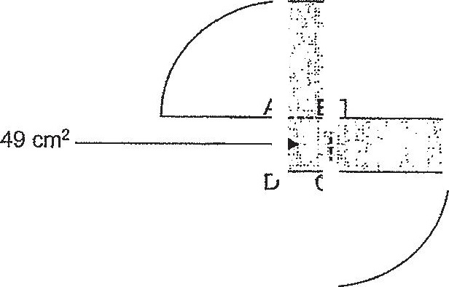

(a) Find the radius of each quarter circle.

(0) Find the total area of the quarter circles.  
(Take x= 22 )

