17, A rectangular tank contained some water at first. A tap was then tumed | Do not write  
on to fill the tank completely with water. It was turned off at the end of _| in this space  
90 minutes. The graph below shows the amount of water in the tank at  
the end of 890 minutes.

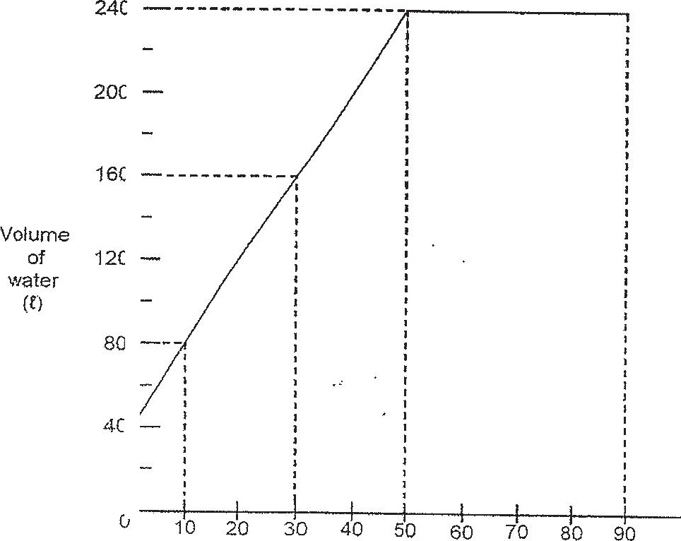

+  
  
i  
  
1  
  
.  
1 7  
t  
  
1  
  
1  
  
t 1  
  
I }  
  
I i  
  
:  
  
!  
  
1 }

(a) In one minute, how many litres of water flowed from the tap? |  
  
|  
  
(b) How many litres of water overflowed from the tank at the énd of 90 !  
minutes?

