13. Mrs Lee baked 16 gingerbread men and 18 gingerbread trees using | ¥o nol write  
552 g of flour, The amount of flour she used for 4 gingerbread men was | in this space  
the same as that for 7 gingerbread trees.

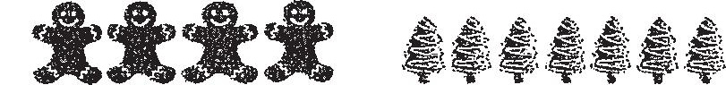

(a) How many gingerbread trees coula sne Dake with ine same  
amount of flour used for 16 gingerbread men?

(bo) What was the total mass of flour used for a gingerbread man and a  
gingerbread tree?

