16. Stickers were sold only in big sheets of 60 stickers each and smail | Do not write  
sheets of 25 stickers each. in this space



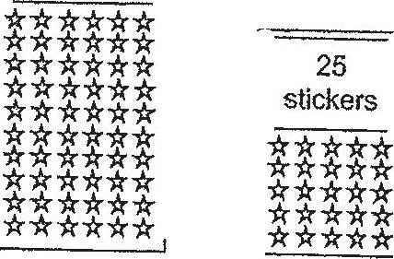

Big sheet Smail sheet |  
Andy and Ben bought the same number of sheets of stickers. Andy and  
Ren each bought some big sheets of stickers, Andy bought 8 small  
sheets of stickers while Ben bought 17 small sheets of stickers.



(a) What was the difference in the total number of stickers betweer  
Andy and Ben?

(>) Ben gave away all the big sheets of stickers that he had bought. As  
a result, ne had 735 fewer Stickers than Andy. How many sheets of  
stickers did each boy buy?



