17. Sian glued a large cube A, a smaller cube B and 3 1-cm cubes | Do not write  
together to form a solid as shown in Figure 1. He painted the solid | inthis space  
including its base.  
  
He then glued a rectangular block C to the solid in Figure 7 to form  
another solid as shown in Figure 2. Cube A and block C have the same  
base area.

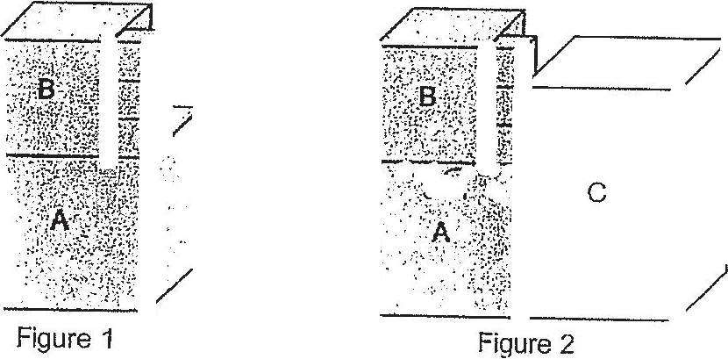

(a) What fraction of the length of an edge of cube A was the length of  
an edge of cube B?

(6) Find the painted area of the solid in Figure 4.

(C) Stan glued some more 1-cm cubes to the solid in Figure 2 to form  
a larger rectangular solid. What was the least number of t-cm  
cubes used?



