





SUBJECT : MATHEMATICS PAPER 1

TREM : PRELIMINARY EXAMINATION

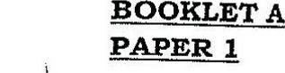





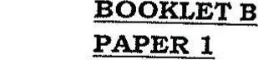

=+9 =3x!  
Q16. 2+9 =ix-

Q1L7. 0.2% +100 = 0.002

Q13. Angle DGE = 180° - 99° ~- 40°

Angle AGF = 360° - 50° - 50° - 45° _ 499 _ 990

019.

