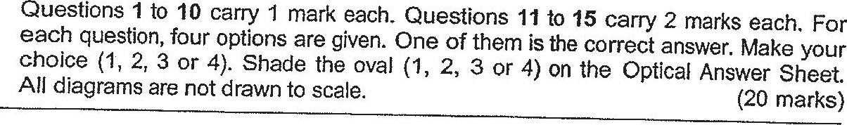

1. What does the digit 7 in 65.47 stand for?









2. How many sixths are there in 32 ?



3. Justin attended an enrichment class for 4 h 55 min. He left the class at  
5 p.m. What time did he arrive at the enrichment class?

(1) 3.05 p.m.

(2) 3,55 p.m.

(3) 4.05 p.m.

(4) 6.55 p.m.