Q4.

Ans: (a) library  
(b ) The square above the art

Qs. 2B+5S = 37.5







38 = 37.5



= 12.5

Ans: 12.5cm

O6 (a) SE = k







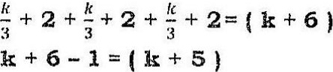

Ans: (a) $ (2k)  
(b) $8fk+5)