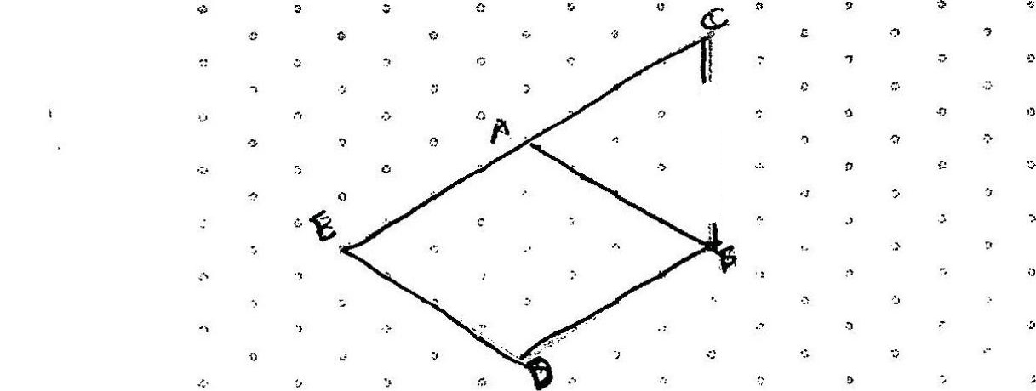









Q8. (a) 100% w = 120



100% - 20% = g0%

SO%w = 1.2x380

(b) 210-180 = 30

36 ~  
1g0 2% 100% = 16.7%



(Be 16.7%