







4¢x1.7=6.8

+x 2.25 =9

9+ 6.8 = 15.8



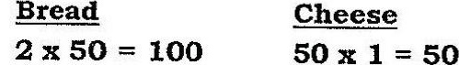



IZ@+1L=13 10 + 1= 11 (packets)  
13 x8 = 104 11 x 5 = 55 (amt. of sandwiches can make)



(amt. of sandwiches can make)

13 + 1 = 14.



112+ 2 = 56 (amt. of sandwiches can make)







(amt. of sandwiches can make)

bread.

15 x1.7= 25.5

12 x 2.25 = 27

27+ 25.5 = 52.5

Ans: {a} $15.80

{b) - $52.50