4. Which one of the following is likely to be the height of the monkey bars  
measuring from the bar to the ground?

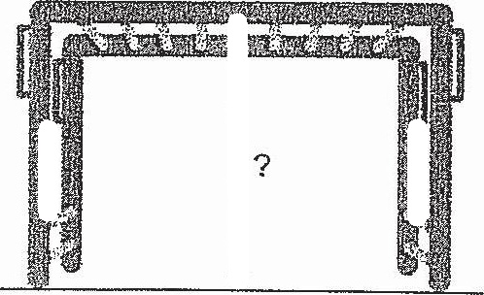

(1} 0.02 m

(3) 0.20m

5. What i 10  
hat is the value of 3 2y+ 1 when y= 37