Use the information below to answer Questions 6 and 7.

The graph shows the number of chicken nuggets eaten by each child at a party.

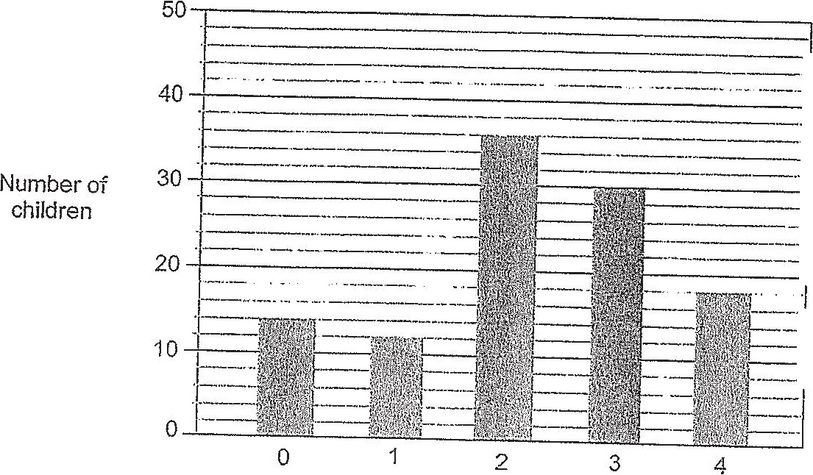

Number of chicken nuggets eaten by each child

6. How many children ate 2 or more chicken nuggets each?

f. How many more children ate chicken nuggets than those who did no}?