S. A,B,C,D and O are poinis on a square grid. Which point when joined to O is  
perpendicular to MN?

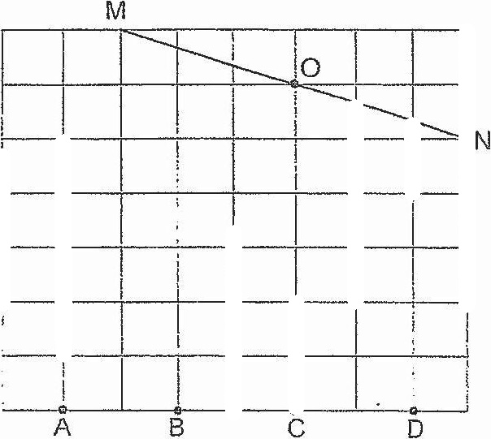



J. The price of a pair of shoes is $80 before 5% discount.  
What is the price of ihe pair of shoes after discouni?

