10. Which one of the following fractions is larger than 4 ?



11, In a survey, each pupil was asked to name a favourite colour,  
The pie chart showed their choices.

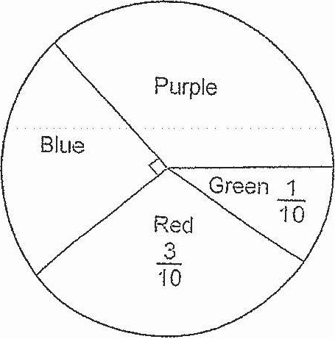

19 pupils chose blue as their favourite colour. How many pupils chose  
purple as their favourite colour?