12. Davian rolied a toy car wheel from point P on the floor towards a wall on a  
straight path. The wheel with centre O had a diameter of 6 cm. There was a  
distance of 156 cm between point P and the wall.

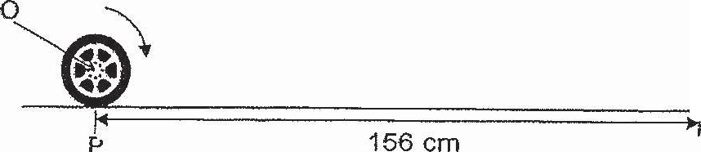

. 43. Hector had a bag of sweets. After giving 35 sweets to his classmates and =

of the remainder to his neighbours, he was left with + of the bag of sweets

ne had at first. How many sweets did Hector give away?

