14, A reciangular paper OPQS is folded along the dotied line OQ as shown  
before folding. After folding, ORP is a straight line.

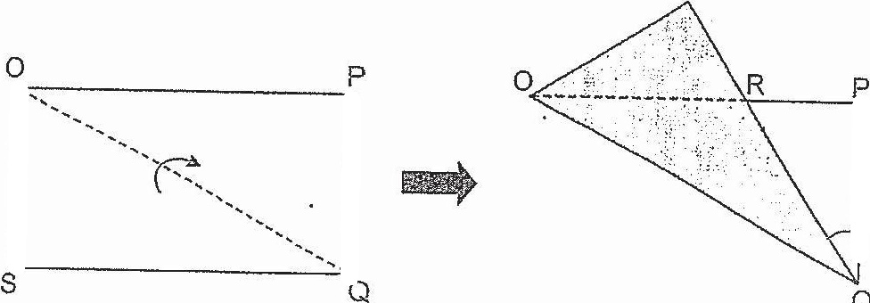

Before folding

Which of the following siatemeni(s) is/are true?

siatement A: “SRO+ ZPQR = 90°.

Siaiement B : ORQ is an isosceles triangle.

Siatement C : The area of the reciangular paper OPQS before folding is  
equal to the area of figure OSRPQ after folding.

(1} Aonly





