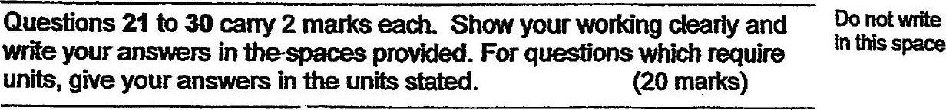

21. The average of a set of three different 2-digit numbers is 32. Find the  
largest possible number in the set.





22, Pansy baked some cookies. !f she gives each of her inends &  
cookies she will have no remainder. If she gives each of them 4  
. cookies instead, she will have 24 cookies left. How many cookies  
did Pansy bake?





23. [t takes 90 minutes fo fill a container compietely with water. What  
fraction of the container will be filled with water in 1 hour? Give your  
answer in the simplest form.



