24. The figure below is made up of 3 similar squares, each of side Bo not  
16.cm. What is the area of the shaded triangle? write in this

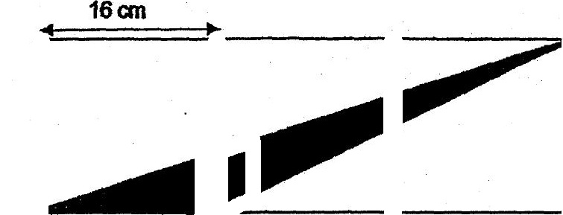



. 2 .  
  
28. A box contains beads of three different cofours. 3 of them are blue.  
The ratio of the number of green beads to that ofthe red beadsis  
4:3. What is the ratio of the number of blue beads to the number of



26. Alihad 3 fimes as much money as Nathan at first. Afler All spent $30  
and Nathan received $48 from his mother, both boys had the same  
amount of money. How much. money.did Nathan have in the end?



