



28. The line graph below shows the number of stickers Hilary has at the  
beginning of each month from January to April.

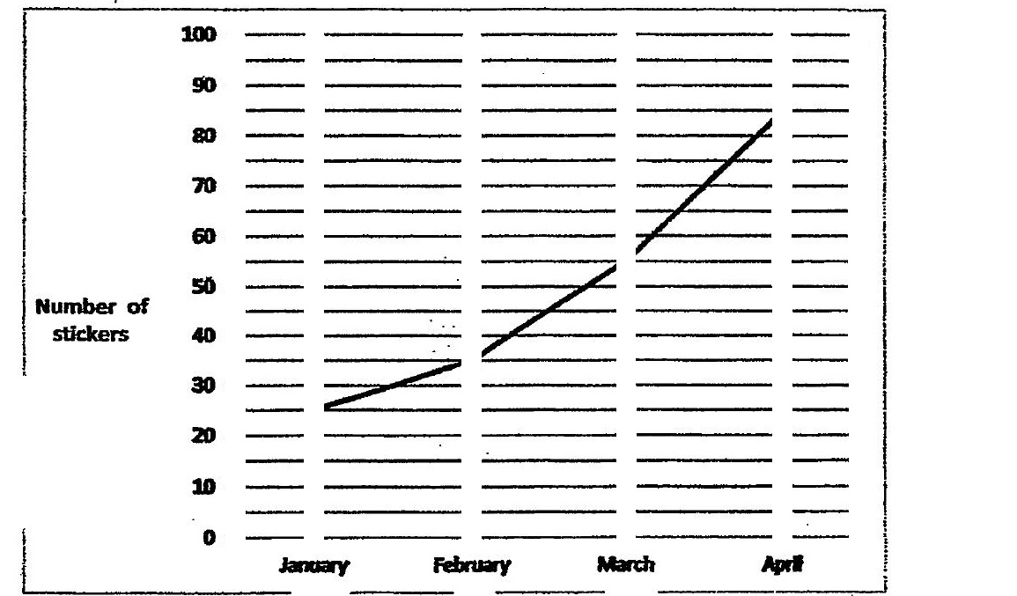

What was Hilary’s average increase in the number of stickers per  
month from January to April? :

