23. in the square gnd below, PQ and QR form two sides of the | Donotwrite  
parallelogram PQRS. Complete the drawing of the parallelogram | in this space  
PORS.

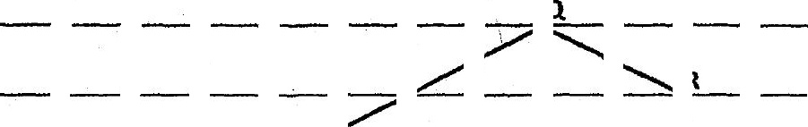





30. Anumber has 15 as a factor.

Each statement below is either true, false or not possible to tell from  
the information given. For each statement, put a (v) in the correct  
column.

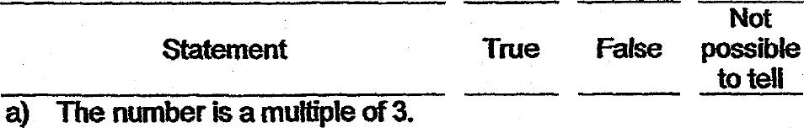



- End of Booklet B ~-

