9. the bar graph below shows the number of packet drinks sold on Do not write  
Monday. The bar that shows the number of soft drinks sold has not _| it this space



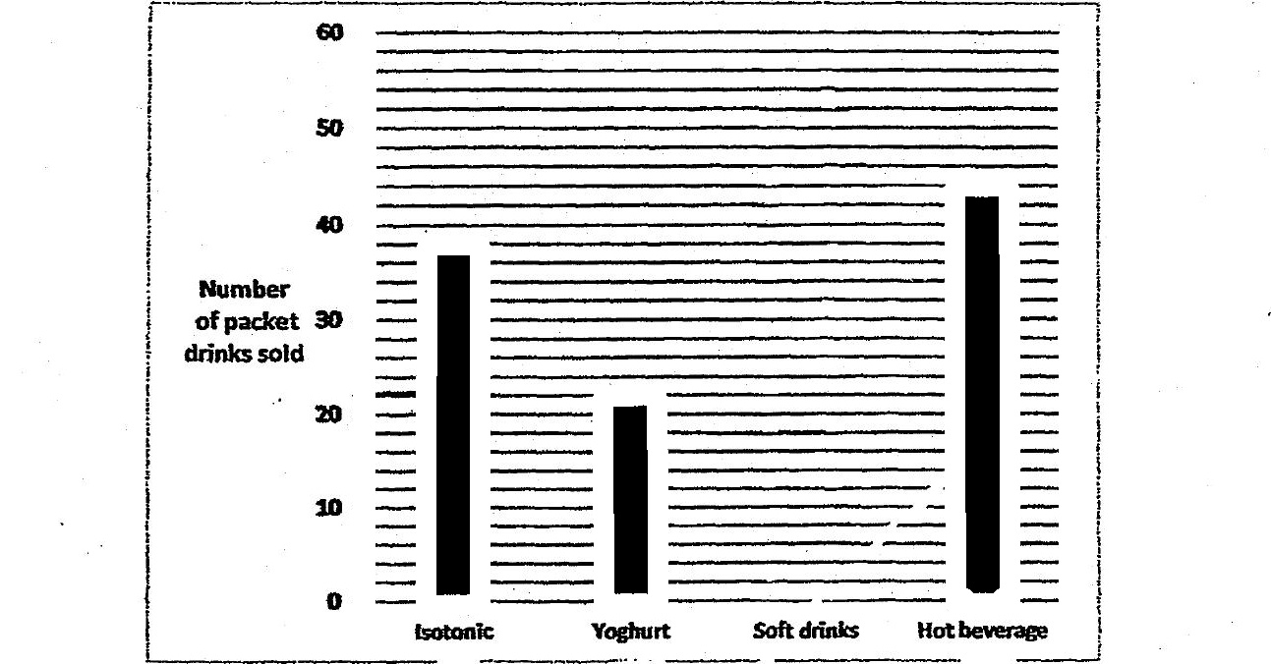

(a) How many more packets of hot beverage were soid than  
tsotonic drink?

(b) 35% of all the drinks sold were soft drinks. In the graph  
above, draw the bar to show the number of packets of soft  
drinks sold.



