









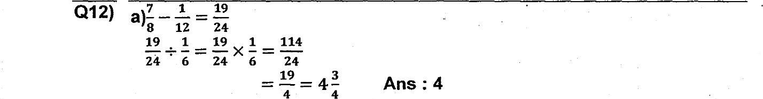



10 cars -—- 2500 x 10 = 25000

25000 + 3000 = 28009









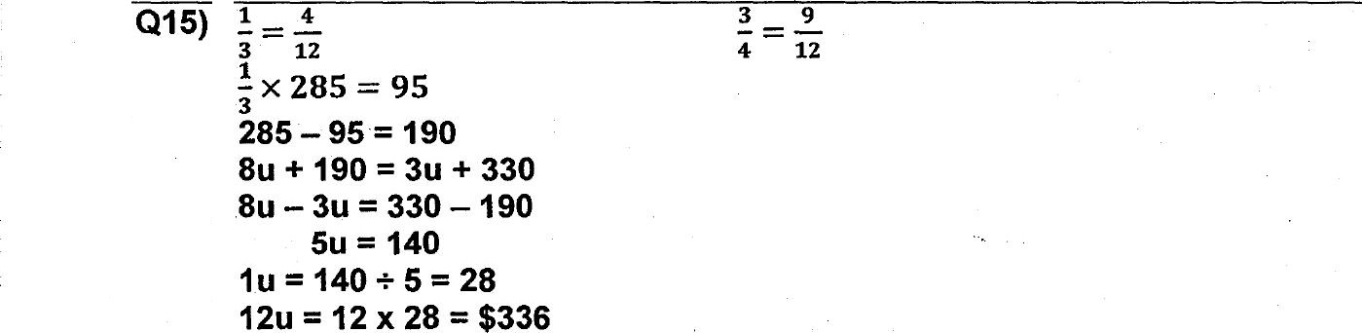





100% —> or x 100  
Ans : $150