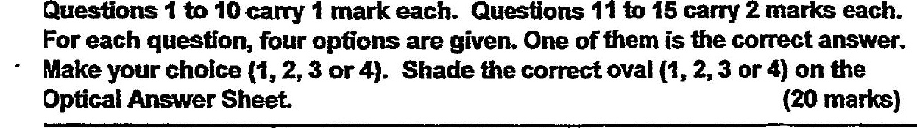

number to the nearest thousand.









2. . 3 6  
Find the value of 475

3. Express 1.7 as a percentage.

(41) 0.017 %





