< in the figure, AB and CD are straight lines. Which one of the following  
statements is true? .

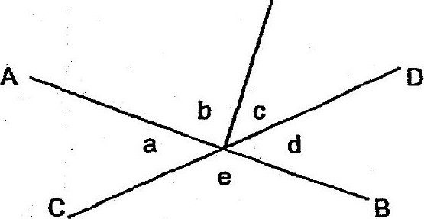





(3) fa =/ZeorZd



day? Leave your answer in terms of y.







